**EXPT NO: 6 A python program to implement face recognition DATE: 23/10/2024 using Support Vector Machine.**

# AIM:

To write a python program to implement face recognition using SVM.

# PROCEDURE:

Implementing face recognition using svm involves the following steps:

## Step 1: Import Necessary Libraries

First, import the libraries that are essential for data manipulation, visualization, and model building.

from sklearn.datasets import fetch_lfw_people import matplotlib.pyplot as plt

from sklearn.model_selection import train_test_split from sklearn.svm import SVC

from sklearn.pipeline import make_pipeline

from sklearn.decomposition import PCA as RandomizedPCA from sklearn.metrics import accuracy_score

## Step 2: Load the Dataset

The dataset can be loaded and display the first few faces of the dataset.

faces = fetch_lfw_people(min_faces_per_person=60) fig, splts = plt.subplots(2, 4)

for i, splts in enumerate(splts.flat): splts.imshow(faces.images[i], cmap='magma') splts.set(xticks=[], yticks=[],

xlabel=faces.target_names[faces.target[i]])

# OUTPUT:

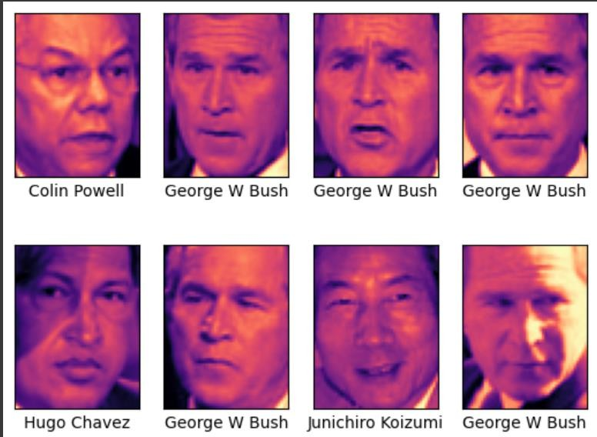\

**Step 4: Split the Data**

Split the data into training and testing sets. Fit the dataset to the model.

X = faces.data y = faces.target

X_train, X_test, y_train, y_test = train_test_split(X, y, test_size=0.4, random_state=42)

## Step 5:

**Dimensionality Reduction**

Reduce the dimension using Principal Component Analysis (PCA) Fit the model with SVC.

pca = RandomizedPCA(n_components=150, whiten=True, random_state=42) svc = SVC(kernel='rbf', class_weight='balanced')

model = make_pipeline(pca, svc) model.fit(X_train, y_train)

## Step 6: Make Predictions

Use the model to make predictions on the test data.

predictions = model.predict(X_test)

## Step 7: Evaluate the Model

Evaluate the model performance using metrics like Accuracy Score and confusion_matrix

# OUTPUT :

predictions = model.predict(X_test)

accuracy = accuracy_score(predictions, y_test) print(accuracy)

matrix = confusion_matrix(predictions, y_test) print(matrix)

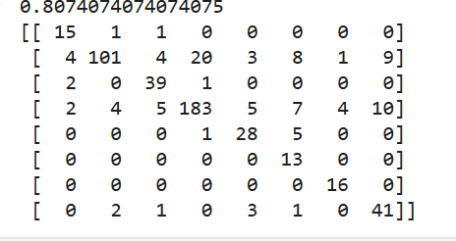

# RESULT:

This step-by-step process will help us to implement face recognition using SVM and analyzed their performance.